Project Design Phase-II
Technology Stack (Architecture & Stack)

Date | 30 June 2025
Team ID | LTVIP2025TMID50516
Project Name | EV Visualization Tool for Electric Vehicle Price and Range Analysis
Maximum Marks | 4 Marks

Technical Architecture:
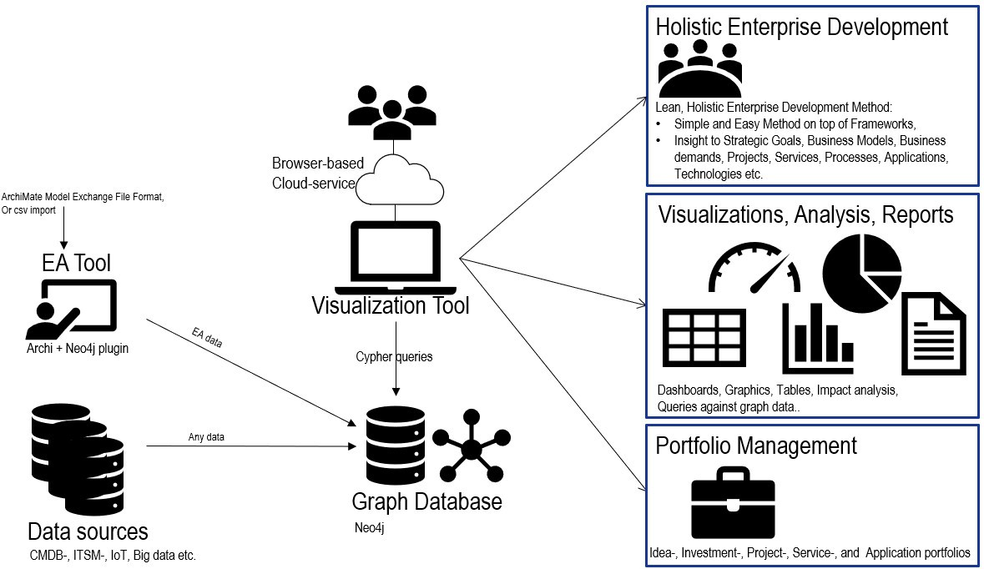

Table-1 : Components & Technologies:
S.No | Component | Description | Technology
1. | User Interface | . How users interact with the tool | Tableau Public Web UI
2. | Application Logic-1 | Data preprocessing and transformation | Python (Pandas, NumPy)
3. | Application Logic-2 | CSV file merging and cleaning | Python (Pandas)
4. | Application Logic-3 | Dashboard design and user interaction setup | Tableau Public Dashboards
5. | Database | Data stored in structured files (CSV format) | CSV Files (Locally stored)
6. | File Storage | Stores the preprocessed data files and original datasets | Local Filesystem
7. | Infrastructure (Server / Cloud) | Application developed and visualized on local system | Local System + Tableau Public Cloud

Table-2: Application Characteristics:
S.No | Characteristics | Description | Technology
1. | Open-Source Frameworks | Data manipulation and processing libraries | Python (Pandas, NumPy, Matplotlib)
2. | Security Implementations | Tableau Public requires login; local files stored securely | Tableau account authentication
3. | Scalable Architecture | Dashboards can be updated with new data and republished | Modular CSV + Tableau design
4. | Availability | Hosted on Tableau Public – available online 24/7 | Tableau Public Cloud Platform
5. | Performance | Lightweight dashboards, optimized charts, small da load | Technology used  ta size ensures fast

